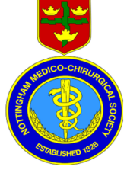

Nottingham Medico Chirurgical Society
Origami Workshop
Booking Form

Nottingham Medico Chirurgical Society
Origami Workshop
30th November 2024

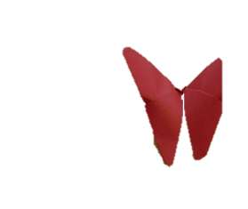
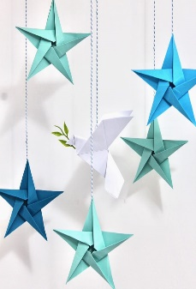
Origami Workshop £10 per person – Start time 10:00am
For a second year running David Bogod will be instructing us on the technique of Origami.
Last year we made the 5 pointed Star, Butterflies and a pop open box. What is in store for us this year! If you want to find out, fill out the application form or email admin@medchi.org.uk.
Location:- Med Chi Room, PGMEC, City Hospital Campus, Hucknall Road, NG5 1PB

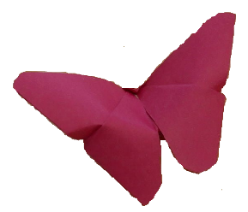
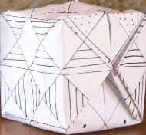

Name: |  |  | Mobile:
Email:
Payment
Date:

To confirm your booking, please complete the above form or email admin@medchi.org.uk. Places are limited, so please ensure that you send in your booking form and make a £10 payment to Lloyds Bank.

Payment please via BACS to: Lloyds Bank—Nottingham Medico Chirurgical Society. Account No: 42057468. Sort Code: 30-99-09 Ref: (Your Name & Ori)

